RFID based Toll Collection Sysyem

PROJECT FOCOUS AN ELECTRONIC TOLL COLLECTION SYSTEM USING RADIO FRIQUENCY IDENTIFICATION TECHNOLOGY

The RFId system uses tag ,through which information embedded on the tags are read by RFID reader,The proposed system eliminates the need for motorists and toll authorities to manually perform ticket payments and toll fee collection,respectively. Thus it is a more efficient toll collection by reducing traffic and eliminating possible human error

Thissystem allows the vehicle drivers to pass the toll tax booths without stopping at the toll boots .the toll amount is deductd from thre RFID card . this RFID card is rechargeable and account is stored on the recoards

BLOCK DIGRAM….

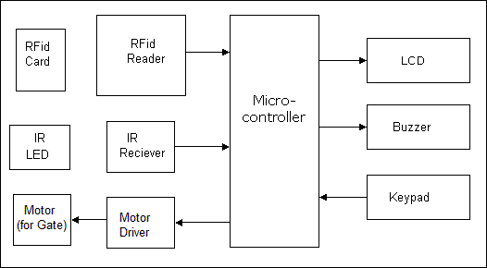

1. Receiver: We are going to use a Infrared receiver. It is used to detect that vehicle has passed away from the electronic toll collection plaza.

2. Transmitter: Infra-Red transmitters used are IR LEDs. IR rays from transmitters are reflected from the vehicle and are received by the receiver.

3. Microcontroller: This is the CPU (central processing unit) of our project. We are going to use a Microcontroller of 8051 family. The various functions of Microcontroller are like

I. Reading the RFID card number from the RFID reader. II. Sending this data to LCD so that the person operating this project should read various informative messages. III. Sensing the command given using keypad and receiving signal from the IR receiver. IV. Sending the data to the motor or buzzer depending upon the RFID card number and balance inside the card.

4. LCD: We are going to use 16×2 alphanumeric Liquid Crystal Display (LCD) which means it can display alphabets along with numbers on 2 lines each containing 16 characters.

5. DC motor and Motor Driver: We are going to use a DC motor to open the gate. A motor driver IC is required to drive the motor.

6. RFID card reader: This is one of the most important part of the project. It reads the unique number from the RFID cards and sends it to the Microcontroller.

Applications and Advantages:

1. RFID automated gate project can be used in Toll collection plaza on Highway.

2. RFID based automatic gate can be used in octroi collection booths for faster access.

Future Development:

1. We can send this data to a remote location using mobile or internet

2. Voice alarm system can be added tElectronic toll collection system allows the vehicle drivers to pass the toll tax booths without stopping at the toll booths. The toll amount is deducted from the RFID card. This RFID card is rechargeable and account is stored on the records

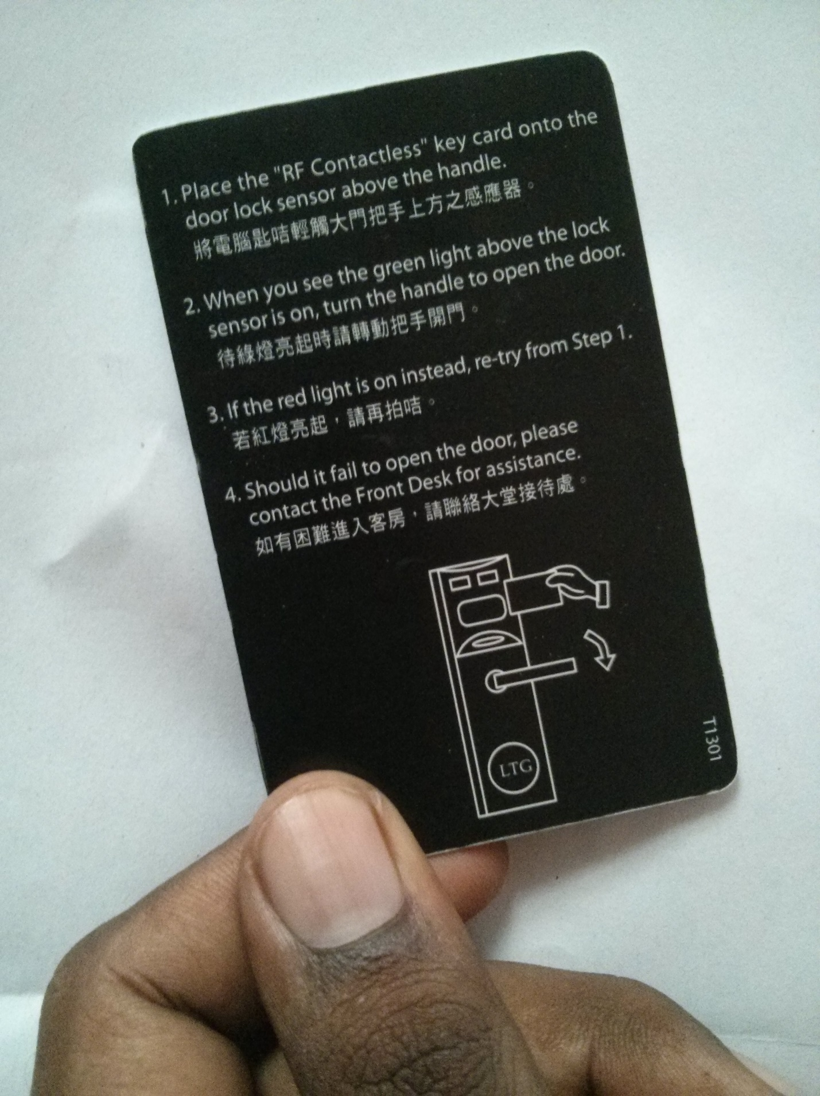

Automatic toll collection system will have two benefits.

First benefit is that movement of traffic will be much faster as user will not wait to give the money because, driver has to just show the RFID card in-front of the card reader. And then the RFID based automatic gate control system will open the gate to pass through.

Second benefit is that driver doesn’t have to carry the money each time. He/she will just recharge the RFID card by certain amount and will use this card each time he travels. This is little bit similar to using credit cardd

o indicate that card has insufficient balance & persons can’t pass through rfid based automatic toll gate system